I developed an addiction to apples in 1999. At the start of that year I was vibrating in the frequency of my other addictions and coming to the end of my ten-year career as a life model. These paintings by my wife Alison were some of the last ever painted of me in November of the same year. We re-discovered them recently and wondered about why they had been painted – what had motivated the apple paintings?
13th April 1999 My 39th birthday was lost in a haze of alcohol. I needed to get April out of the way; the important thing was to focus on May. And Manchester United. And the Impossible Dream.
16th May Manchester United won the Premier League, finishing one point ahead of Arsenal.
22nd May Manchester United won the FA Cup beating Newcastle 2-0
26th May For me, the auspicious occasion of the Champions League Final justified an extra early start to the drinking. My brother Steven later remembered me arriving at the pub with a 2 litre bottle of Strongbow, which was almost empty. In extra time, by some crazy miracle and an indomitable spirit, Manchester United beat Bayern Munich to win the cup. The historic treble dream had come true. My memories of this greatest of all days are sadly sketchy.
27th May I filled my rucksack with two bottles of Cava and a four-pack of Stella Artois and went to Deansgate to join the sea of delirious fans, who were gathered to welcome the heroes back to Manchester atop an open top double decker bus. I was aware of being in some pain as I stumbled around the city. I was spiralling away.
Friday 28th May whilst sitting in Manto Bar on Canal Street nursing a pint, I realised I had to get out of town.
Saturday 29th May Alison, Dicky our dog and I set off in the green VW camper van to the hills of Lancashire. But I couldn't move from a horizontal position on the back seat. After I declined an offer to walk to a pub, Alison realised there was something seriously wrong and drove us back to Manchester. I spent a sleepless night with a crippling and excruciating pain across the middle of my body, unable to eat or drink anything.
Sunday 30th May I waited till it got light, then agreed to be driven to MRI. Following some blood tests I was taken to High Dependency and received the diagnosis of a near-fatal attack of alcohol induced pancreatitis.
I left hospital a week later, sober and detoxed. I did not drink another drop of alcohol for the rest of 1999. Instead I developed an Ashtanga Yoga obsession and an intense apple addiction, so much so that whilst journeying to Scotland in September 1999, the dashboard of our camper van became completely covered in those tiny apple stickers.
In November that year Alison and I separated for the next 10 months. Alison asked me to life model for these paintings during that winter in an attempt to understand what was happening to us. Only now 18 years later when I am learning to fully accept younger myself, have I begun to understand the deep significance of these paintings.
When one is ready to receive truth, art reveals love.

Another Adele, February 2017
Another Adele
A is For
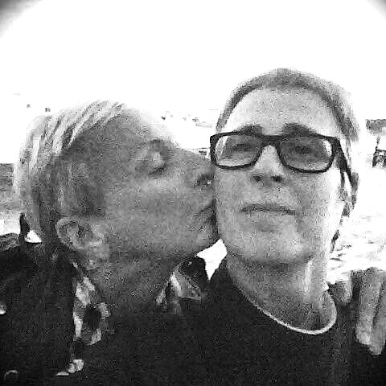

Another Adele is a collaboration between Adele Fowles, performance artist and massage therapist, and contemporary artist and curator Alison Kershaw. Alison and Adele work together to develop live art installations, performances and actions. The name ‘Another Adele’ was arrived at when Adele felt so frustrated that her once fairly unusual first name suddenly became one of the most recognised on the planet around 2008.
Adele and Alison have been friends for 25 years, lived together as a couple for 20 years, and were married as civil partners in April 2012 in a spectacular ceremony for friends and family in Blackpool – one of their first joint productions. The work they do together uses (though not exclusively) material from their own autobiographies.
This latest piece A is For has been commissioned by Wonder Women and Superbia and examines a particular moment in 1999 when Adele was diagnosed with alcohol-induced pancreatitis following Manchester United’s historic treble cup win.
Although working together was always on the cards and often discussed over the years, Another Adele’s first work was Dancing The Davids, shown as part of the International exhibition UN-REST at Victoria Baths, Manchester in 2014.
See more at alison-kershaw.com/another-adele

This project is supported by a grant from Superbia. Superbia Grants provide financial support for LGBT events as part of Manchester Pride’s commitment to the quality and diversity of cultural events taking place throughout the year in Greater Manchester. http://superbia.org.uk

